**Arweave (AR)** MP

**Current Price**: $59.86

**Token Type**: Utility token for File storage and tx fees.

**Circ. Token Supply**: 50.108m

**Max. Token Supply**: 66m

**Market Capitalisation**: $3bn

**24-Hour Volume**: $71.1m

**Launch**: Mainnet - June 2018

**Whitepaper**: <https://www.arweave.org/whitepaper.pdf>

**Target Price: $97 (Mktcap of Filecoin)**

**Historical Chart**

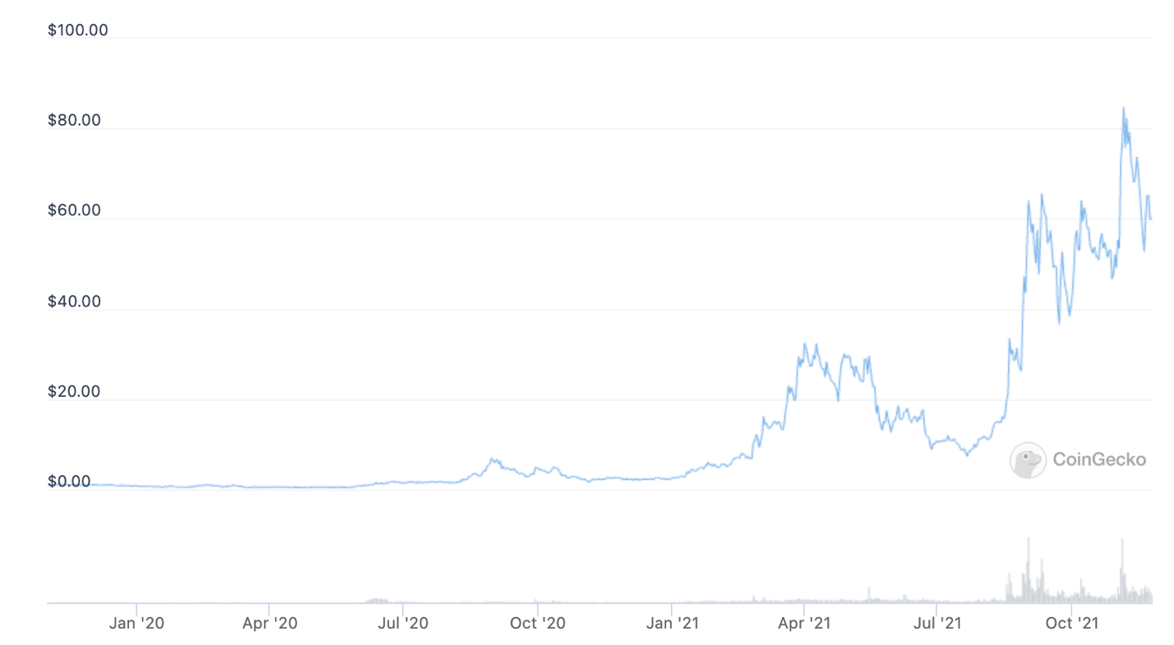

**Overview**

Arweave is a data storage protocol built on block weave technology. Arweave is developing an underlying network where data can be stored forever and accessed on its permaweb, a secondary layer where data is accessible in a human-readable manner (e.g. via web browsers).

**Investment Thesis**

**Current Data Storage is Impermanent and Centralised – prone to censorship, change, deletion.**

Most data storage today is highly centralised, and temporary. Users pay cloud storage companies like AWS, Azzure monthly fees to store their data on their servers. Most of the internet’s data is stored similarly. This data is completely at the mercy of the centralised entity that controls the servers – and is susceptible to change, removal or censorship. Arweave looks at providing a decentralised storage network to overcome all of these issues – making data universally accessible.

**Strong Economic model incentivising long term data storage.**

Data stored on the internet is far from permanent. Centralised servers will store your data only as long as you continue paying a monthly subscription fee – the moment that fee stops, your data can be deleted. Close to 95% of the information on the internet is lost every 20 years.

Arweave has created a unique economic model that incentivises decentralised data storage via nodes – through a long term payment system in AR tokens over time.

**Building a Permanent Internet**

Arweave is looking towards building a permanent internet – a web of applications, information and data – that is permanent, prone to censorship. Arweave does this by incentivising developers to build applications on its blockchain – by providing a profit sharing concept with the protocols – aligning their incentives with Arweave’s. Protocols receive fees from Arweave based on the usage/transactions they generate on the blockchain. More the activity – more the fees. Arweave could potentially become the go to platform for decentralised news, social media etc.

**Providing Storage as a Service to other Enterprises and Blockchains.**

While Arweave may be the go to blockchain for applications that value permanence, they can also serve as an infrastructure layer to enterprises including other blockchains that need to store important metadata in perpetuity. We are already seeing this with Solana, that uses a proof-of-history consensus mechanism – thereby needing to keep their data permanent. As blockchains grow, so will the demand for more and more permanent storage.

**Catalysts:**

* In Dec 2020 - Solana and Arweave partnered for Solana’s high performance data storage needs. This provides Arweave with a constant stream of demand for its storage, and thus, its token.
* Decentralized NFT, Gaming, Social Media apps will all require vast amounts of storage – Currently a single AAA game will require between 25GB-100GB of data storage. NFT’s will want to be stored permanently. Solana has allocated $100m focused on building the Gaming and NFT ecosystem while they Mhave also partnered with Reddit Founder Alex Ohanian to allocate another $100m for decentralized social media.
* Permaweb application development – as more and more applications look to build for permanence – Arweave will be the main destination.

**TAM & Valuation:**

* The primary goal for Arweave is to become the go-to service provider for decentralised long term data storage, providing for web2 data storage, as well as web3 data storage requirements.

Quantifying the TAM taking into consideration current web2 cloud storage Market:

Current Market Size : $74.6bn projected to grow to $390bn by 2028. IT and telecommunications is 16% of this market – with data that is of historical significance – and hence has a higher need of permanence.

Current Market Cap of web3 File storage protocols :

Arweave – $3bn

Filecoin – $6.2bn

Siacoin – $1.01bn

Storj – $760m

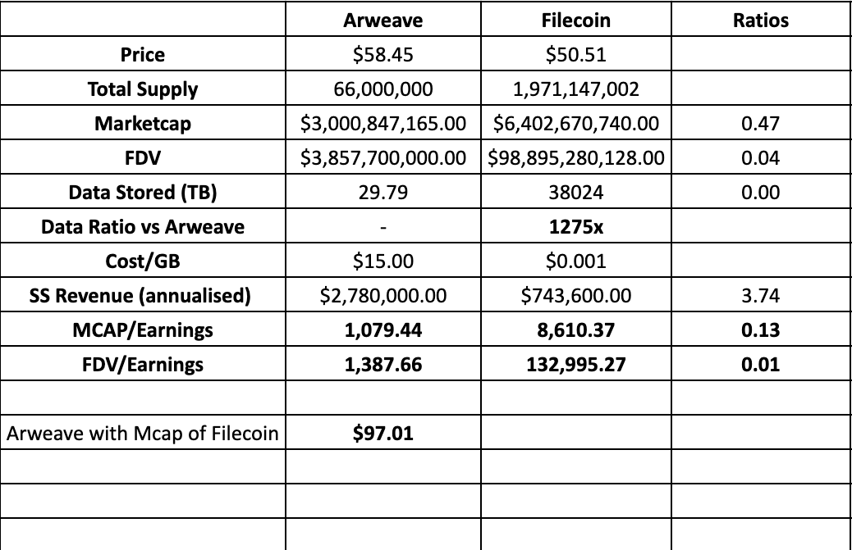

We can try valuing the token based on potential revenues earned. Currently the protocol stores 1200x less data than its competitor Filecoin – yet is higher in terms of supply side revenue earned. Assuming data capture increases between 100x and 1200x – we can assume revenues will increase by the same amount – as costs are upfront and fixed.

Conservative – assuming revenues and data capture increase by 250x in Y1 and grow 10% YoY.

Token Price - $47.78

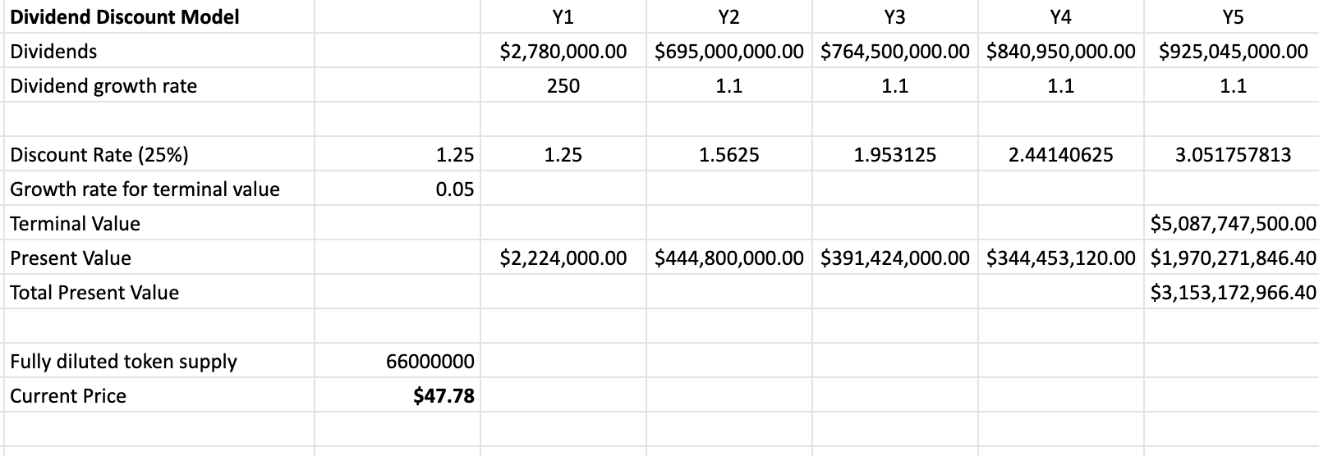

Moderate – assuming revenues and data capture increase by 500x in Y1 and grow 20% YoY.

Token Price - $116.39

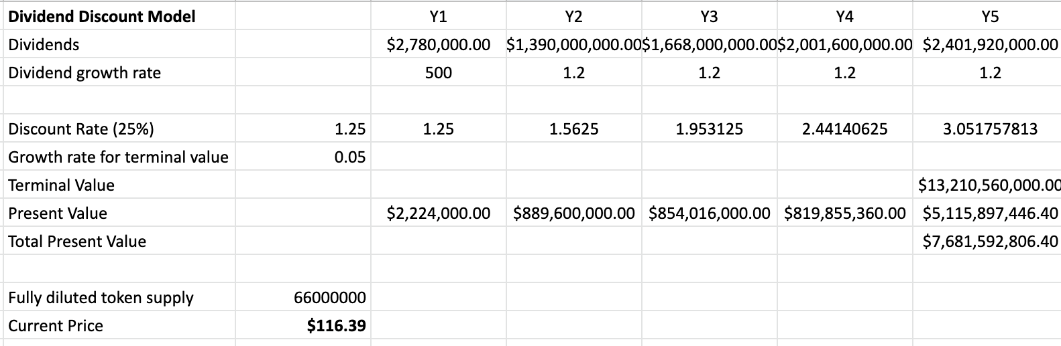

**Bullish –** assuming revenues and data capture increase by 750x in Y1 and grow 25% YoY.

Token Price - $192.11

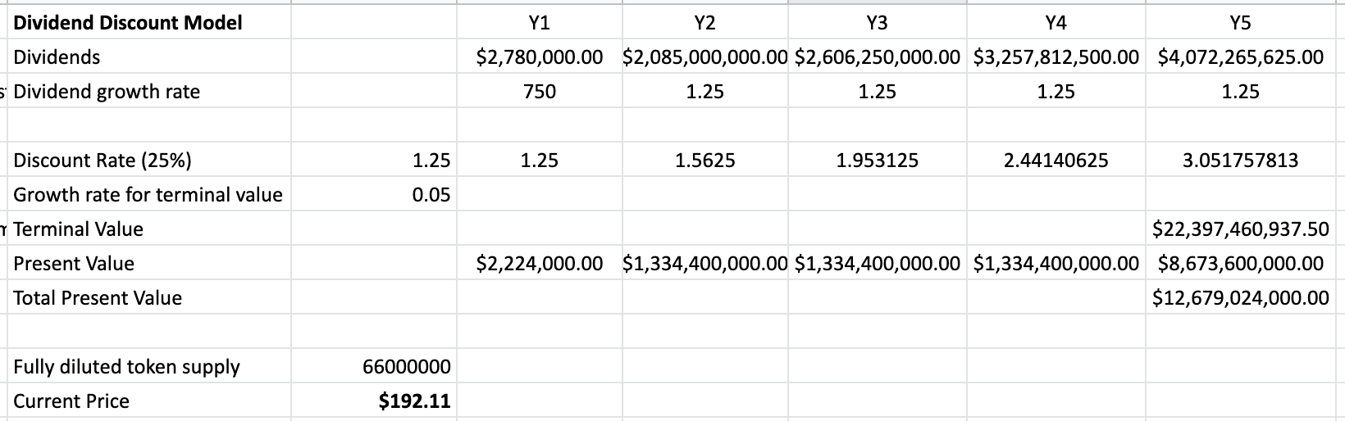

**Industry Outlook**

* Filecoin, Siacoin and Storj – a few alternatives all offer a different value proposition for storage vs Arweave – they charge a recurring fee for temporary file storage – not permanent file storage.
* Arweave costs are significantly higher than its competitors – however, it is a one-time fee. The rest charge subscription fees on a recurring basis per gb of data stored.

**Competitors**

* Traditional competitors – AWS, Azzure.
* Crypto Competitors – Filecoin, Siacoin, Storj.

**Technology:**

Arweave’s blockchain, and economic incentives model run on 4 core components:

**Blockweave:** In the case of blockweave, unlike other blockchains, nodes do not need to download the whole previous blockchain to begin to fulfil key network functions – which is made possible using block hash lists and active wallet lists. When new nodes join the network – they download the current block and receive the entire wallet list as well as the block hash lists.

**Proof of Access:** Proof of access is a novel consensus mechanism that produces a positive externality of data storage. Instead of competing to burn as much electricity as possible, miners compete to provide as many replications of the data held in the system as they can. Further, as the blockweave expands in size, the amount of electricity expended in the mining process decreases.

**Wildfire:**

It is a system that solves the problem of data sharing in a decentralized network by making the rapid fulfillment of data requests on the network – a necessary part of network participation.

It works by creating a ranking system local to each node – which determines how quickly new blocks and transactions are distributed to peers, based on how quickly they respond to requests and accept data from others.

**Blockshadows:** In order to support a network that allows for long-term on-chain data storage, the Arweave needs a system that supports unlimited sized blocks. The Arweave achieves this by using a system that decouples transaction distribution from that of block distribution in the network. This allows only a ‘shadow’ of the block to be moved around the system (the instructions necessary to rebuild the block from its constituent transactions), rather than full block itself. This means that the information required to process large blocks can be distributed across the network in just a few kilobytes

**AR Tokenomics:**

The value of AR is derived from:

1. Transaction fees paid on the network – for data storage, data retrieval.

2. Fees from Interactions with Permaweb applications.

3. Fees from AR token transfers.

Total supply is 66,000,000 AR.

Genesis Block: 55,000,000 AR

Block Rewards: 11,000,000 AR.

Genesis Token distribution: 38.5 % sold.

No clarity on the rest.

Advisors - 2.9%: 1,595,000 AR

Project Team – 13% - 7,150,000 AR (5-year vest – 20% a year)

Development Fund – 19.1% - 10,505,000 AR

Future Project use: 26.5% - 14,575,000 AR.

According to the [blockexplorer](https://viewblock.io/arweave/addresses) – 9 addresses hold 22m AR. (nearly 50% of circulating supply)

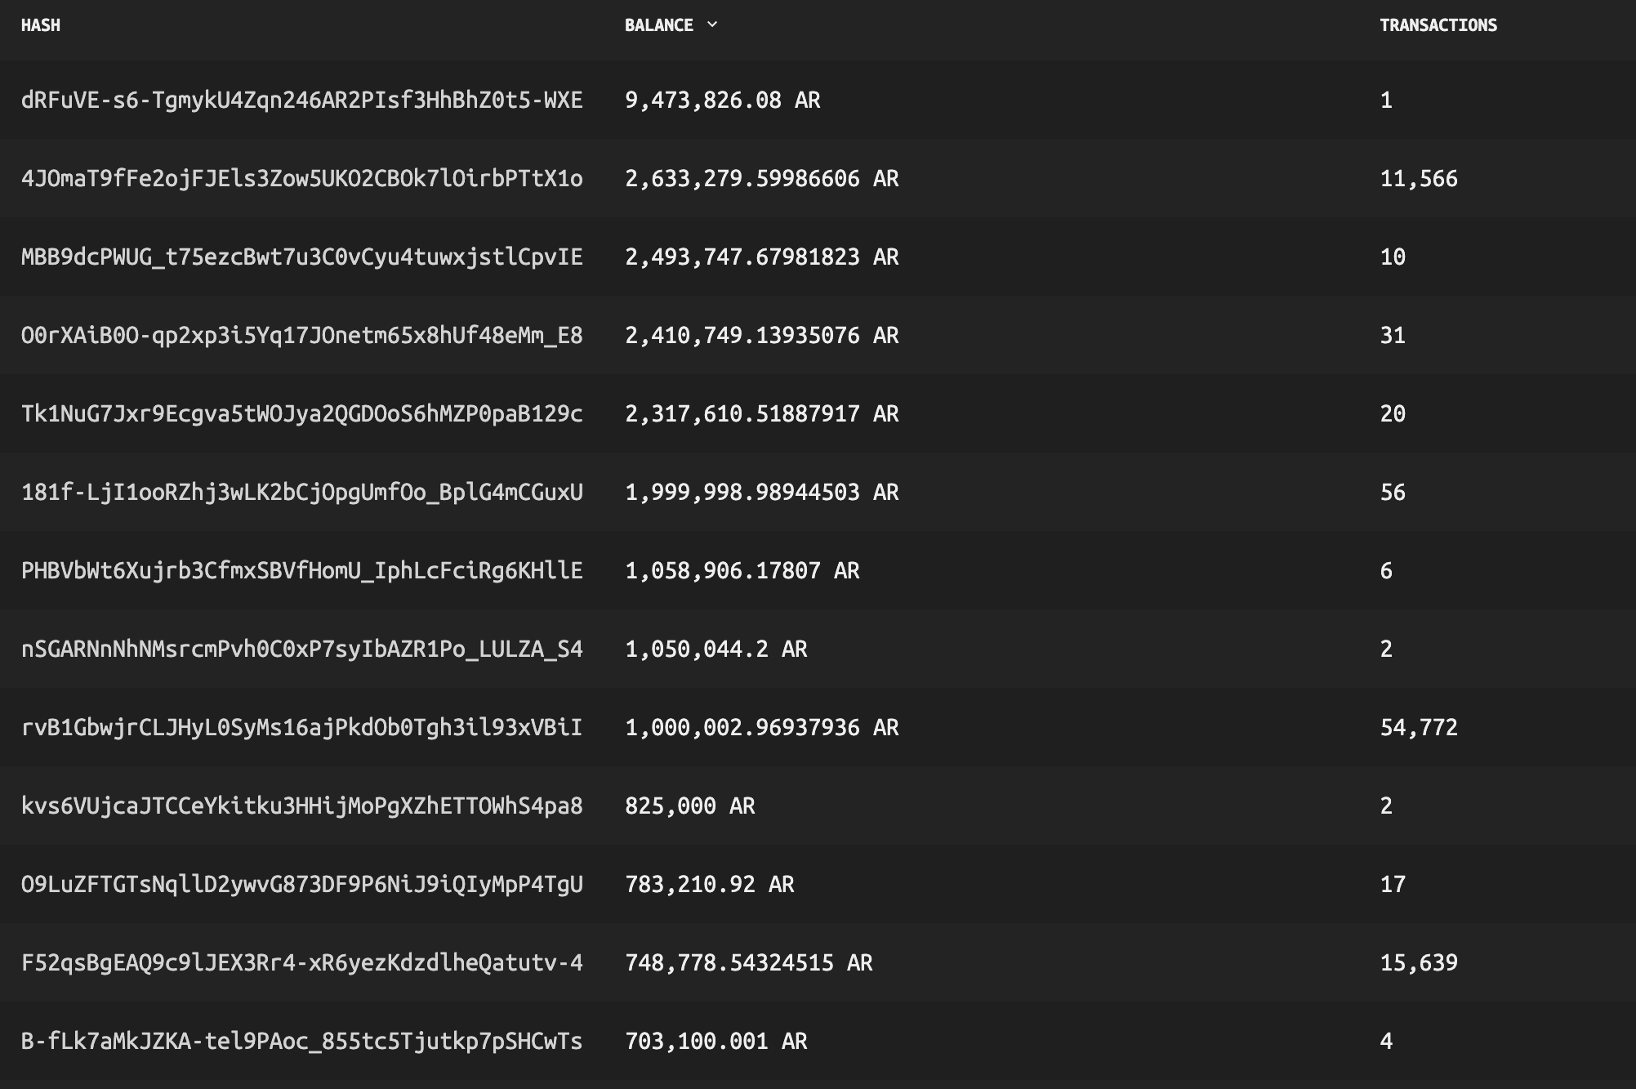

**SWOT Analysis**

Strengths:

1. Only charges a one-time fee for data storage vs a recurring fee. Proves to be cheaper over the long run.
2. Data stored on the permaweb is permanently stored.

Weaknesses:

* High cost / storage unit as compared to other alternatives - $15/gb vs $0.001/gb for Filecoin or $0.004/gb for Siacoin. Projects or protocols that value short term costs more than permanence will be unlikely to use Arweave.

Opportunities:

* Gaming and NFT storage will most likely have to be permanent, leading to potential higher demand for Arweave storage.
* Solana using Arweave as its storage layer for high performance data – will lead to a steady stream of demand. Other blockchains/enterprises can mirror this.
* Arweave storage now natively available on Polygon.

Threats

1. Over-reliance on Solana growth.
2. High % of supply of AR concentrated to 9 addresses.

Token Metrics

|  |  |  |  |
| --- | --- | --- | --- |
| **Market Cap** |  | **Supply** |  |
| Liquid Marketcap: | $3,000,847,165.00 | Liquid Supply: | 33,394,701.00 |
| Reported Marketcap: | $3,857,700,000.00 | Reported Supply: | 66,000,000.00 |
| Y2050 Marketcap: | - | Y2050 Supply: | - |
|  |  | % Reported Supply: | 50.60% |
| Marketcap Dominance: | 0.00% | Liquid Inflation Rate: |  |
| **On-Chain Data** |  | **Returns** |  |
|  |  | 1-Month (vsUSD): | 10.62% |
|  |  | 1-Month (vsBTC): | 21.13% |
|  |  | 90-Day (vsUSD): | 123.40% |
|  |  | 90-Day (vsBTC): | 103.59% |
|  |  | 1-Year (vsUSD): | 2260.08% |
|  |  | 1-Year (vsBTC): | 2063.69% |

**Management & Team**

**Founder: Sam Williams and Jesper Noehr (**

**Team Size**: 20+

**CRYPTO-NATIVE DILIGENCE**

Code Audits

As of now, Tokemak has been audited by Block Apex and Hacken. This covers all the smart contracts in the protocol, and the security. All High risk and medium risk issues resolved.

Link to all Audits - <https://github.com/VoirStudio/unipilot-audits/tree/master/protocolContract>

Open-Source Risk (Forking Risk)

* Forking Risk – Protocol smart contracts can be forked. Forking the economic model will not be as simple.

**Resources**

Github: https://github.com/ArweaveTeam/arweave  
Docs: https://www.arweave.org/technology#papers

Code audits:

**Official Channels**

[**Website**](https://www.arweave.org/)

[**Twitter**](https://twitter.com/ArweaveTeam)

[**Discord**](https://discord.gg/3Dad8J7)

Token Utility (What is it used for?)

1. Encoding data into the system and rewarding miners. In order to write a transaction into a block, a user has to pay some AR as a transaction fee- majority of the fee is stored in a treasury and paid to miners over time.
2. Paying for permanent data storage. (Upfront costs) – more the requirement for data storage – more demand for AR.

**How the Protocol generates Revenue**

* Upfront costs for data storage: Current cost 0.26 AR/GB translates to roughly $15.5/GB.
* Transaction fees generated off of apps built on the blockchain.

Current Total Data stored: 23.86 TB

Total Revenue generated: $750k.

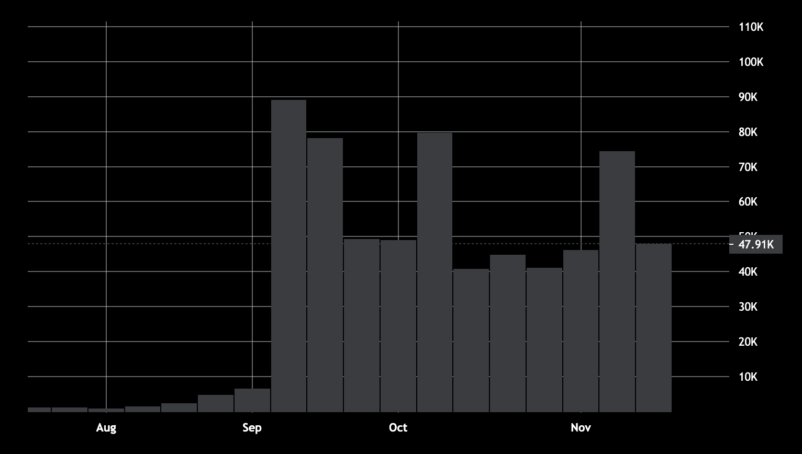

* Demand for storage (measured by data usage) had grown more than 7x between Aug 2021 – Oct 2021. Price for AR went up more than 4x in the same timeframe.
* Revenues also up in the same Aug-Nov timeframe.

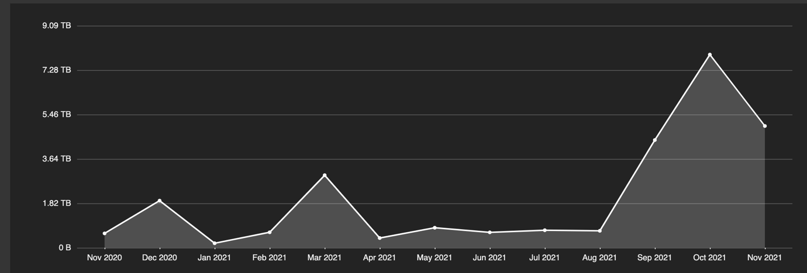

Profit Sharing Tokens: It encourages more developers to build on the blockchain, since they get a share of the network fee that their apps are generating on-chain.

In Dec 2020 - Solana and Arweave have partnered for Solana’s data storage needs – since AR permanently stores data – all the transactions, once validated by Solana’s node operators – will be permanently stored on Arweave. Essentially, Solana’s storage layer is Arweave – all their data will be stored on Arweave.

As the Solana blockchain grows, gains adoption, and has more activity, more the data that would be needed to be stored on Arweave, more the demand for AR. AR could potentially become the storage layer for other blockchains as well

* AR Token price mirrors that of the SOL token, over a 1Y timeframe. This could be validation of the thesis that as activity on Solana increases – so does the storage required – hence demand for AR is likely to increase. Solana has barely even scratched the surface when it comes to applications running on its blockchain – with most activity around DeFi currently, and some around NFTs. As adoption, and range of applications grow – so will the increased requirement of storage.
* Decentralized NFT, Gaming, Social Media apps will all require vast amounts of storage – for which Arweave will be the provider.
* Solana has allocated $100m focused on building the Gaming and NFT ecosystem while they have also partnered with Reddit Founder Alex Ohanian to allocate another $100m for decentralized social media.

AR Token Price – 1 Y

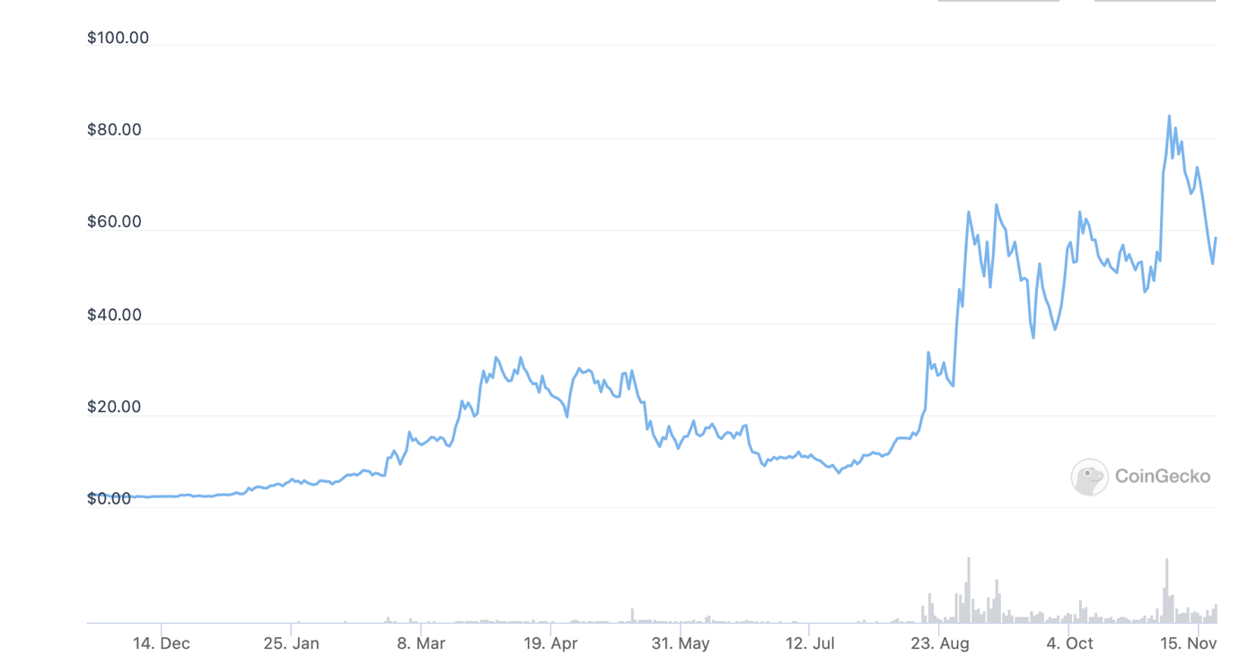

SOL Token Price – 1 Y

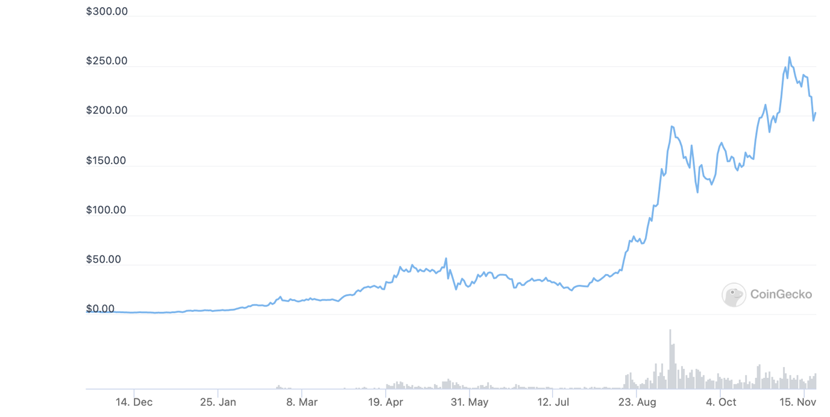

TVL Growth on Solana

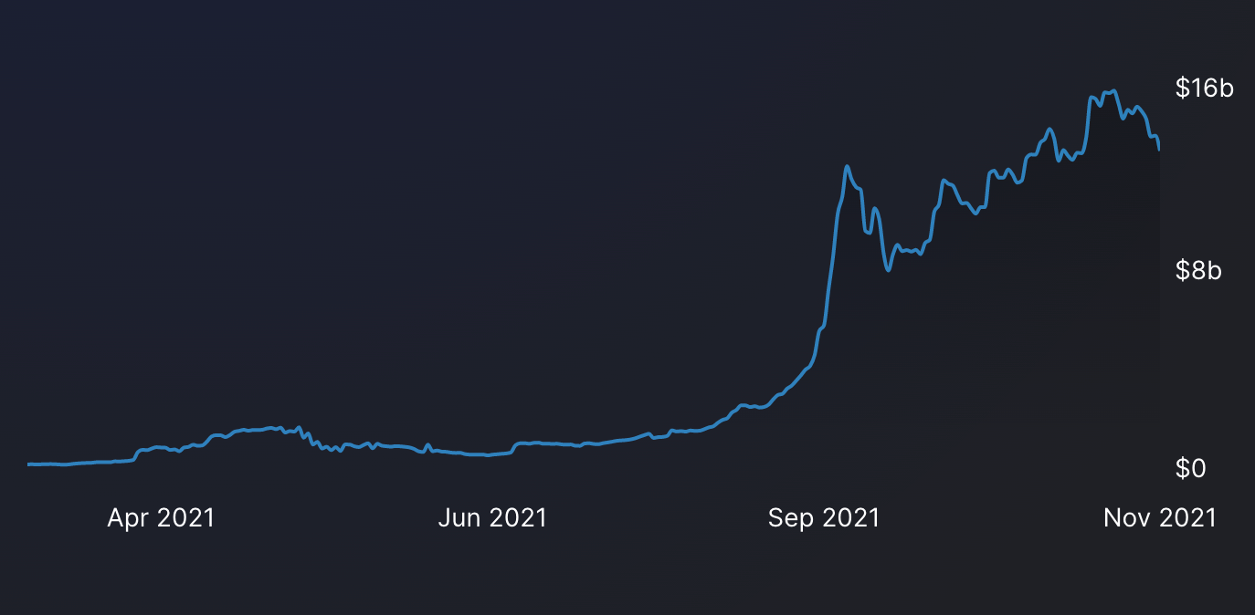

* TVL on 23rd August – $2.5bn
* Current TVL: $12.28bn
* Growth in TVL on the blockchain is a good indicator of usage of the Solana blockchain – across a wide range of DeFi applications.

**Arweave vs Filecoin**

**Long Term Storage vs Temporary Storage**

Filecoin is focusing on storage for more traditional web apps – by looking at providing the lowest cost temporary storage. Arweave is focused on long term data storage – through permaweb + setting up an ecosystem for permanent apps.